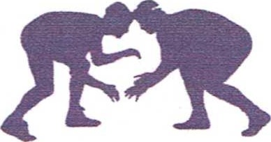
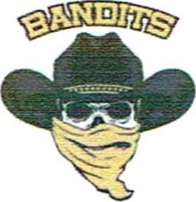
BOILING SPRINGS YOUTH WRESTLING CLUB
PO BOX 89
BOILING SPRINGS, PA 17007
October 2022
Boiling Springs Youth Wrestling Club has been committed to children in our community for over 50 years! Students from kindergarten through grade 6 have benefited from the teaching, and discipline our program provides. This wouldn't be possible without our dedicated coaching staff, parents, and sponsors.
In addition to a significant time and monetary investment by both our coaching staff and parents, the club also depends on sponsorships from organizations to fund equipment needs and key activities that make our club successful, such as wrestling events that our club hosts and / or attends. As a sponsor of the Boiling Springs Youth Wrestling Club, you are not only investing in our community, but investing in development of strong minds and bodies of students for years to come. Please consider a sponsorship in Boiling Springs Youth Wrestling Club. Details below.
For each tier of sponsorship, your company will receive various advertising and recognition from the Boiling Springs Youth Wrestling Club. Donations are also welcome! Tier details are as follows:

WHITE Sponsor - $100
•Your company and logo displayed on banner hung at all youth wrestling events held at Boiling Springs High School •Logo displayed on our website www.banditwrestiing.net

SILVER Sponsor - $300
•White Sponsor benefits
•Your company name and logo on our team's T-shirts

PURPLE Sponsor - $500
•White and Silver Sponsor benefits
•"Thank You" plaque with team photo to display at your business

GOLD Sponsor - $700
•White, Silver and Purple Sponsor benefits
•Your company name and logo displayed on the BSYWC Bandits wrestling mat for all BSYWC events held at Boiling Springs High School

Other Amount (Donation)

With more than 350 wrestlers and their families attending wrestling events each week, your sponsorship is sure to be noticed. From the T-shirts worn year-round in our community, families and clubs visiting our website weekly for event details and schedules, to your logo on a banner or a wrestling mat, your sponsorship investment will make a difference!
To ensure timely ordering and distribution of our T-shirts, as well as to get banners and signage printed, please check the level and submit this form with payment by November 1st to the above address. For your convenience, you can also register and donate through our website: https://www.banditwrestling.net/sponsors. We can also come to you! Please feel free to call or email us to setup a time to pick up your sponsorship! For logos, please email logo information to banditwrestling@gmail.com.
Thank you in advance for your consideration and continued support! If you have any other questions or concerns regarding our program, please direct them to Ryan Eby, President at 717-440-2520, or by emailing us at banditwrestling@gmail.com.
Sincerely,
Boiling Springs Youth Wrestling Club, EIN 46-4146273

